SECTION A – All questions are worth one mark

X | 8 | 7 | 9
6
3
7
1. Complete this times table grid

1 mark
2. Calculate 421 x 23

……………
1 mark
3. 675 ÷ 15

……………
1 mark
4. Round the following:

a) 83 (nearest 10) ……………

b) 794 (nearest 100) ……………

c) 8870 (nearest 1000) …………….
1 mark
5. Work out

- 5.4 x 100 ……………

- 35.2 ÷ 100 ……………

c) 0.27 x 1000 ……………
1 mark

6. Work out 60% of £420

…………..
1 mark
7. Find the area of the parallelogram.

5cm
8cm
9 cm

……………
1 mark
8. Solve 3x + 5 = 17

…………..
1 mark
9. Work out :

a) 3 - 7 ……………

b) (-7) + (-2) ……………

c) (-5) - (-3) ……………
1 mark

10. If a = 7 and b = 4 what is:

a) 4a + 3b

……………
b) 3a - 2b

……………
1 mark

SECTION B – All questions are worth one mark

- Write in the missing numbers

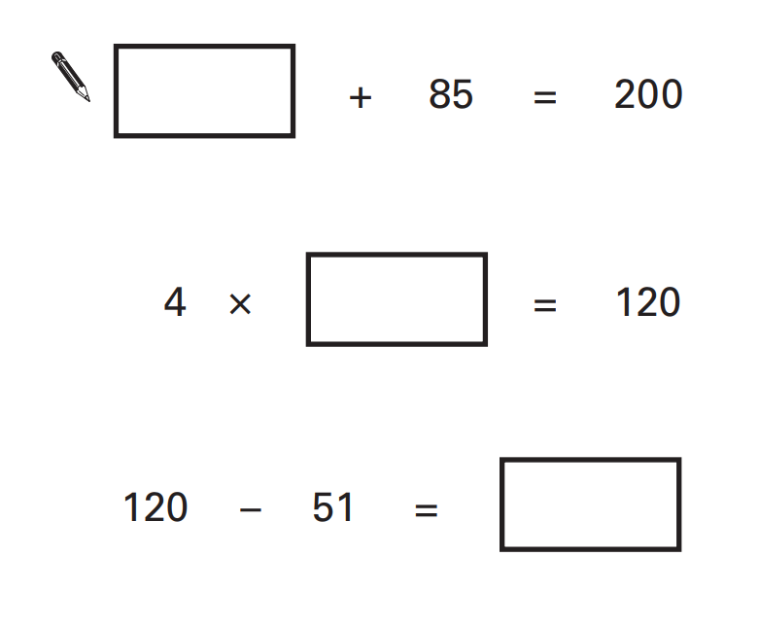 1 mark

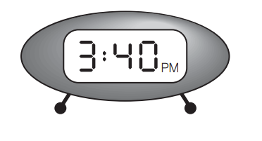
- A clock shows this time.

How long is it from this time until 5pm ?

…………………

What time was it quarter of an hour before the time on the clock?

………………….
1 mark
- A swimming pool is 25 metres long and 10 metres wide.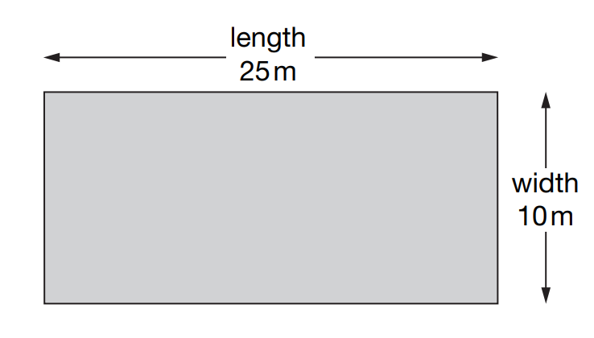
Odafe swims 5 lengths.
Ateh-Su swims 12 widths.
How much further does Odafe swim than Ateg-Su?

………………….
1 mark
- Match each decimal number with its fraction equivalent.
One has been done for you.
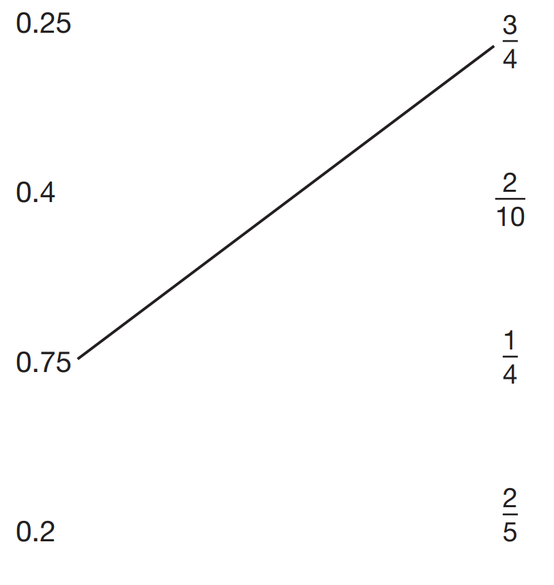

1 mark
- Calculate 45.3 x 6

………………….
1 mark
- Adebiyi has 6 cubes.
He sticks them together to make this model.
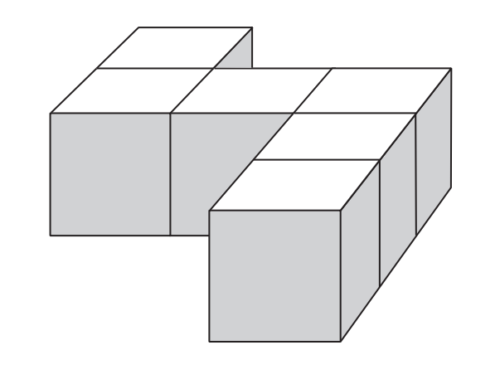
He paints the sides of the model grey all the way around.
He leaves the top and bottom of the model white.
How many of the cubes in the model have exactly two faces painted grey?

………………….
1 mark
- Titilayo thinks of a number.

She adds half of the number to a quarter of the number.

The result is 60.

What number did Titilayo think of?

………………….
1 mark
- Shade two squares and one triangle to make this design symmetrical about the mirror line.
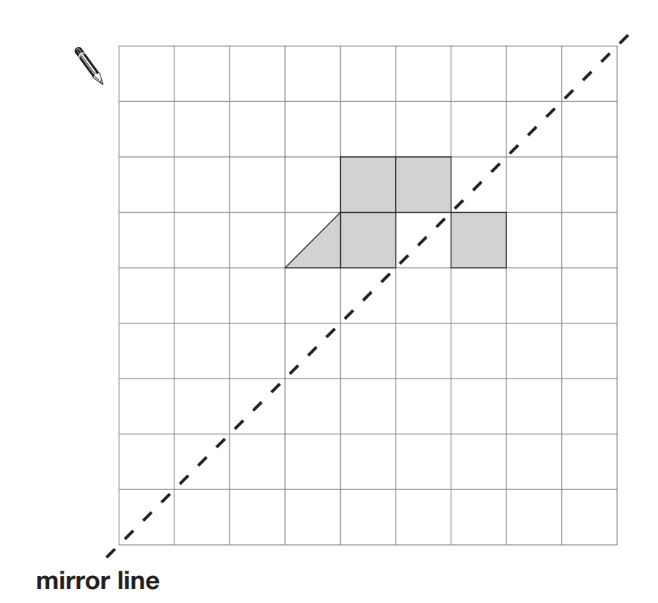

- Write the correct sign >, < or = in each circle.
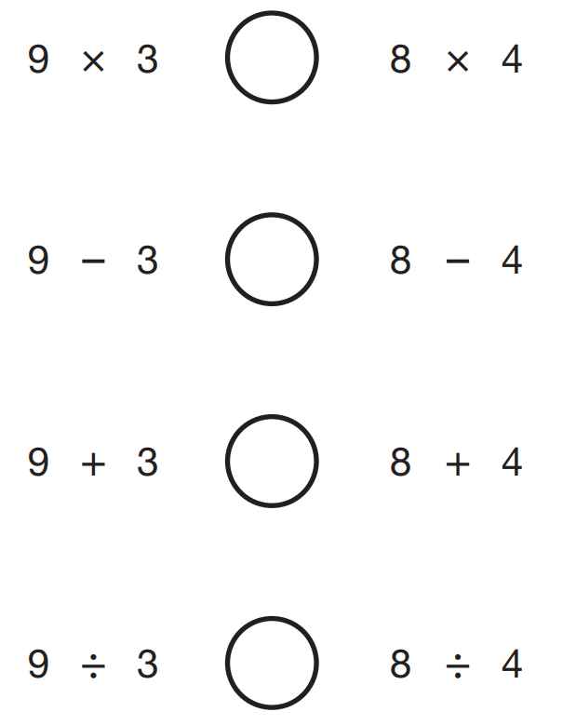

………………….
1 mark
- A and B are joined by a straight line on coordinate axes.
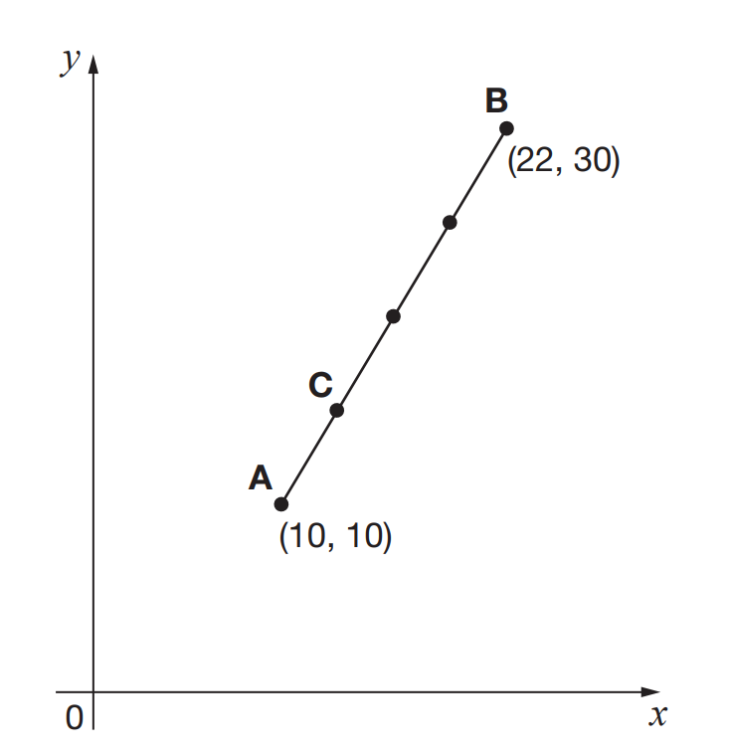

The dots are equally spaced. What are the coordinates of C?
………………….
1 mark
SECTION C – All questions are worth two marks
- What is the mean of two thirds and four ninths?

………………….
2 marks
- In Semilore’s pocket there are 8 orange sweets, 4 lime sweets and 4 strawberry sweets. What is the smallest number of sweets she must take out of her pocket to be sure that she takes out at least one of each flavour?

………………….
2 marks

- How many minutes are there from 11:11 until 23:23 on the same day?

………………….
2 marks
- The diagram shows three squares of the same size. What is the value of x?
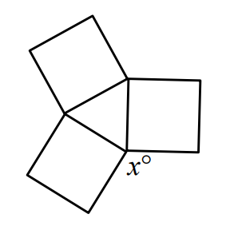

………………….
2 marks
- Temisayo has a lot of tables and chairs in his house. Each rectangular table seats eight people and each round table seats five people. What is the smallest number of tables he will need to use to seat 35 guests and himself, without any of the seating around these tables remaining unoccupied?

………………….
2 marks
- In the diagram shown, all the angles are right angles and all the sides are of length 1 unit, 2 units or 3 units.
What, in square units, is the area of the shaded regions?
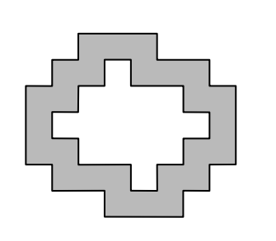

………………….
2 marks
- What is the smallest possible difference between two different nine-digit integers, each of which includes all of the digits from 1 to 9?

………………….
2 marks
- Use these equations to work out how many triangles equal a rhombus.
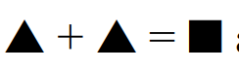

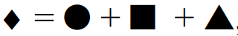

………………….
2 marks
- A 6 by 8 and a 7 by 9 rectangle overlap with one corner coinciding as shown. What is the area (in square units) of the region outside the overlap?
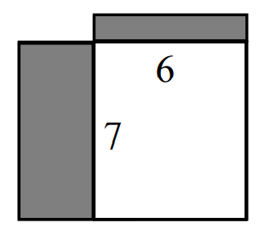

………………….
2 marks
- In the diagram, below, the number in each box is obtained by adding the numbers in the two boxes immediately underneath.
What is the value of x?

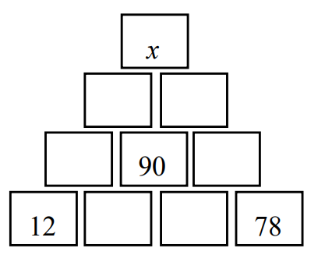

………………….
2 marks

