SECTION A – All questions are worth one mark

X | 8 | 4 | 6
7
3
8
1. Complete this times table grid

1 mark

2. Calculate 3036 ÷ 23

……………
1 mark

3. Round 4.867 to

- 1 dp …………..

- 2 dp …………..

1 mark

4. a) 3.4 x 0.3 …………..

b) 0.6 x 0.7 …………..

1 mark

5. Find 65% of £720

……………
1 mark

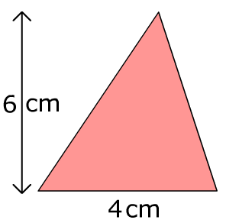
6. Find the area of the triangle

……………
1 mark

7. Solve 4x + 3 = 2x + 17

……………
1 mark

8. Simplify

a) 8y² – 3y² ………………

b) 8x + 4y + 9x – 7y …………………………

1 mark

9. Find the missing angles

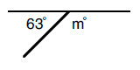

………………

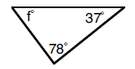

……………
1 mark

10. Split £1200 in the ratio 3:1

……………
1 mark
SECTION B – All questions are worth one mark
- Express 300 as a product of prime factors. Give your answer in index form.

..........................
(1 mark)

- Factorise $x^{3}-5x$ .

..........................

(1 mark)

- Expand and simplify

$\left(x-6\right)\left(x+4\right)$

..........................

(1 mark)

- Solve the following inequality giving your answers as integers

$$-5 < 2x-3≤9$$

..........................

(1 mark)

- Simplify

${\left({2d}^{3}\right)}^{4}$

..........................

(1 mark)
- $PQR$ is an enlargement of $ABC$ .

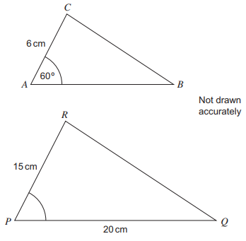
Work out the scale factor of the enlargement.
..........................
(1 mark)

- Make $x$ the subject of the formula $y=2x+4$

..........................
(1 mark)
- The test scores for the $10$ boys in a class are

$$7$$ | $$8$$ | $$5$$ | $$8$$ | $$7$$ | $$9$$ | $$4$$ | $$5$$ | $$3$$ | $$9$$

The mean score for the $5$ girls in the class is $8$
Calculate the mean for this class.

..........................

(1 mark)

- $ABCDE$ is a regular pentagon with centre $O$ .

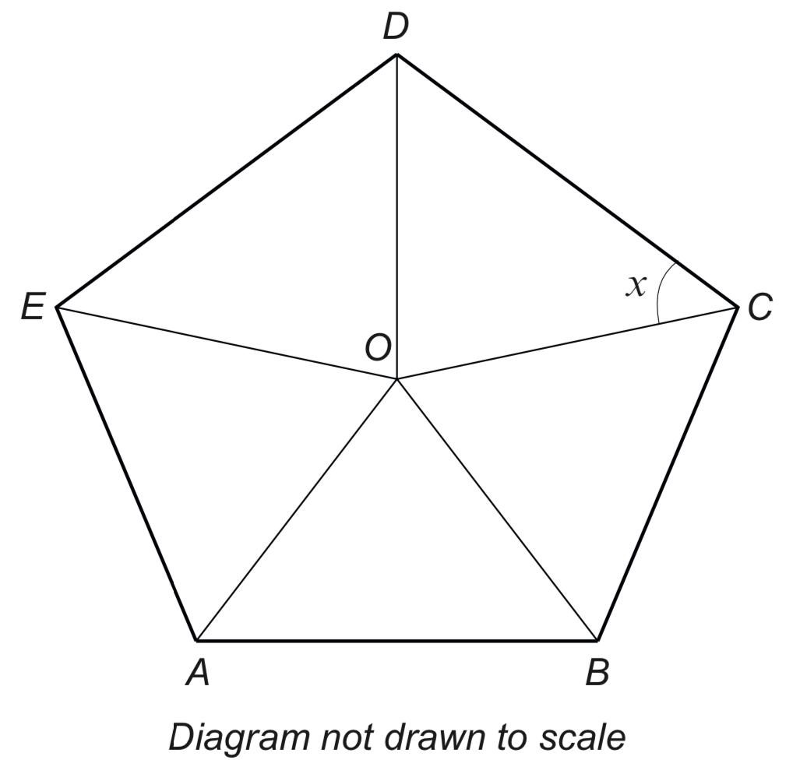

Calculate the size of angle $x$ .

..........................

(1 mark)

- Which is the largest prime number that divides exactly into the
number equal to

$$2+3+5×7$$

..........................

(1 mark)
SECTION C – All questions are worth two marks

- What is the sum of the first five non-prime positive integers?

..........................

(2 marks)

- Semilore’s flock has 55% more sheep than goats. What is the ratio of sheep to goats?

..........................

(2 marks)

- Odafe wants to buy a new house but he doesn’t like house numbers that are divisible by 3 or 5. If all the houses numbered between 100 and 150 inclusive are for sale how many can he choose from?

..........................

(2 marks)

- A standard pack of pumpkin seeds contains 40 seeds. A special pack contains 25% more seeds. Titilayo bought a special pack and 70% of the seeds germinated. How many pumpkin plants did Titilayo have?

..........................

(2 marks)

- Temisayo rolled some dice and was surprised that the sum of the scores on the dice was equal to the product of the scores on the dice. One of the dice showed 2, one showed 3 and one showed 5. The rest showed a score of 1. How many dice did Temisayo roll?

..........................

(2 marks)

- m is an even integer and n is an odd integer. Circle any of the following that gives an odd integer.

3m + 4n
5mn
(m + 3n)²
m³n³
5m + 6n

(2 marks)

- An equilateral triangle is placed inside a larger equilateral triangle so that the diagram has three lines of symmetry. What is the value of x ?
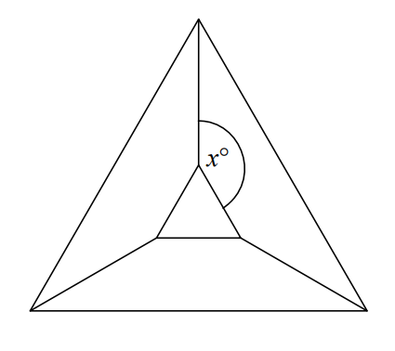

..........................

(2 marks)

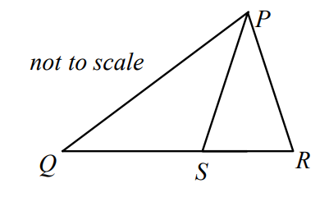
- PQR is a triangle and S is a point on QR.
QP = QR = 9cm and PR = PS = 6cm.
What is the length of SR?

..........................

(2 marks)

- If p, q are distinct primes less than 7, what is the largest possible value of the highest common factor of 2p²q and 3pq² ?

..........................

(2 marks)

- Simplify:

(x ÷ (y ÷ z)) ÷ ((x ÷ y) ÷ z)

..........................

(2 marks)

